**TEST CASE:**

|  |  |  |  |  |  |
| --- | --- | --- | --- | --- | --- |
| **SL.NO** | **SCENARIO** | **INPUT** | **STEPS** | **EXPECTED RESULT** | **ACTUAL RESULT** |
| 1. | Verify whether the number concatenate when we enter alphabets in both the fields | 1st Number-abc  2nd Number-efg  Operation-Concatenate | 1. Open the browser  2.Enter the URL- https://testsheepnz.github.io/BasicCalculator.html  3.Select Build 1  4.Enter the given values in the text field  5.Click on concatenation from operation dropdown  6.Click on calculate | abcdefg should be displayed | abcdefg gets displayed |
| 2. | Verify whether the number gets subtracted when we enter numbers in both the text fields | 1st Number-10  2nd Number-5  Operation-Subtract | 1.Open the browser  2.Enter the URL-https://testsheepnz.github.io/BasicCalculator.html  3.Select Build 1  4.Enter the given values in the text field  5.Click on subtraction from operation dropdown  6.Click on calculate | Number 5 should be displayed in the result | Number 5 gets displayed |
| 3. | Verify whether the number gets added when we entering the both alphabets and numbers | 1st Number-jk  2nd Number-2  Operation-Add | 1.Open the browser  2.Enter the URL-https://testsheepnz.github.io/BasicCalculator.html  3.Select Build 1  4.Enter the given values in the text field  5.Click on addition from operation dropdown  6.Click on calculate | Validation error message should be displayed for entering alphabets in the text field | Not displaying error for entering alphabets in the text field |
| 4. | Verify whether the number gets subtracted when we enter both alphabets and numbers in the text fields | 1st Number-ab  2nd Number-5  Operation-subtract | 1.Open the browser  2.Enter the URL- https://testsheepnz.github.io/BasicCalculator.html  3.Select Build 2  4.Enter the given values in the text field  5.Click on subtraction from operation dropdown  6.Click on calculate | Error message should be displayed for first text field | Error message gets displayed |
| 5. | Verify whether the number gets added when we enter both the alphabets and numbers in the text fields | 1st Number-25  2nd Number-5  Operation-Add | 1.Open the browser  2.Enter the URL- https://testsheepnz.github.io/BasicCalculator.html  3.Select Build 2  4.Enter the given values in the text field  5.Click on addition from operation dropdown  6.Click on calculate | The numbers should be added | The numbers gets concatenated and not added |
| 6. | Verify whether the number gets concatenated when we enter alphabets in both the text fields | 1st Number-qwe  2nd Number-asd  Operation-Concatenate | 1.Open the browser  2.Enter the URL- https://testsheepnz.github.io/BasicCalculator.html  3.Select Build 2  4.Enter the given values in the text field  5.Click on concatenation from operation dropdown  6.Click on calculate | It should accept alphabets and need to perform concatenation | It is not accepting alphabets. |
| 7. | Verify whether the number gets added when we enter numbers in both the text fields | 1st Number-20  2nd Number-20  Operation-Add | 1.Open the browser  2.Enter the URL- https://testsheepnz.github.io/BasicCalculator.html  3.Select Build 3  4.Enter the given values in the text field  5.Click on addition from operation dropdown  6.Click on calculate | Number 40 should be displayed | Number 40 gets displayed |
| 8. | Verify whether the number gets multiplied when we enter numbers in both the text fields | 1st Number-2  2nd Number-2  Operation-Multiply | 1.Open the browser  2.Enter the URL- https://testsheepnz.github.io/BasicCalculator.html  3.Select Build 3  4.Enter the given values in the text field  5.Click on multiplication from operation dropdown  6.Click on calculate | It should be displaying number-4 | Number 4 gets displayed |
| 9. | Verify whether the number gets concatenated when we enter alphabets in both the text fields | 1st Number-wyz  2nd Number-mno  Operation-Concatenate | 1.Open the browser  2.Enter the URL- https://testsheepnz.github.io/BasicCalculator.html  3.Select Build 3  4.Enter the given values in the text field  5.Click on concatenation from operation dropdown  6.Click on calculate | Concatenation should be performed | Error message gets displayed |
| 10. | Verify whether the number gets subtracted when we enter numbers in both the text fields | 1st Number-35  2nd Number-5  Operation-Subtract | 1.Open the browser  2.Enter the URL- https://testsheepnz.github.io/BasicCalculator.html  3.Select Build 4  4.Enter the given values in the text field  5.Click on subtraction from operation dropdown  6.Click on calculate | It should display the number 30 | 30 gets displayed |
| 11. | Verify whether the number gets divided when we enter numbers in both the text fields | 1st Number-10  2nd Number-5  Operation-Divide | 1.Open the browser  2.Enter the URL- https://testsheepnz.github.io/BasicCalculator.html  3.Select Build 4  4.Enter the given values in the text field  5.Click on division from operation dropdown  6.Click on calculate | Number 2 should be displayed | Number 2 gets displayed |
| 12. | Verify whether the user is able to select the integer only checkbox | - | 1.Open the browser  2.Enter the URL- https://testsheepnz.github.io/BasicCalculator.html  3.Select Build 4  4.Click on integer only checkbox | Checkbox should be selected when the user clicks on the checkbox | User not able to select the checkbox as it is in disabled form |
| 13. | Verify whether when the user is able to calculate the special characters along with the number in addition | 1st Number-%  2nd Number-3  Operation-Add | 1.Open the browser  2.Enter the URL- https://testsheepnz.github.io/BasicCalculator.html  3.Select Build 5  4.Enter the given values in the text field  5.Click on addition from operation dropdown  6.Click on calculate | Error message should be displayed for the first number text field | Error message gets displayed |
| 14. | Verify whether the user is able to perform multiplication while entering alphabets | 1st Number-qrs  2nd Number-abc  Operation-Multiply | 1.Open the browser  2.Enter the URL- https://testsheepnz.github.io/BasicCalculator.html  3.Select Build 5  4.Enter the given values in the text field  5.Click on multiplication from operation dropdown  6.Click on calculate | Error message should be displayed | Error message gets displayed |
| 15. | Verify whether the user is able to perform concatenation while entering alphabets | 1st Number-efg  2nd Number-ijk  Operation-Concatenate | 1.Open the browser  2.Enter the URL- https://testsheepnz.github.io/BasicCalculator.html  3.Select Build 5  4.Enter the given values in the text field  5.Click on concatenation from operation dropdown  6.Click on calculate | It should be performing concatenation operation | Concatenation gets worked properly |
| 16. | Verify whether the user is able to perform multiplication while entering alphanumerical values | 1st Number-10  2nd Number-abc  Operation-Multiply | 1.Open the browser  2.Enter the URL- https://testsheepnz.github.io/BasicCalculator.html  3.Select Build 6  4.Enter the given values in the text field  5.Click on multiplication from operation dropdown  6.Click on calculate | Error message should be displayed | Error message gets displayed |
| 17. | Verify whether the user is able to perform addition while entering the values | 1st Number-25  2nd Number-25  Operation-Add | 1.Open the browser  2.Enter the URL- https://testsheepnz.github.io/BasicCalculator.html  3.Select Build 6  4.Enter the given values in the text field  5.Click on addition from operation dropdown  6.Click on calculate | Number 50 should be displayed | Number 50 gets displayed |
| 18. | Verify whether the user is able to perform concatenation while entering special characters | 1st Number-#$  2nd Number-^&  Operation-Concatenate | 1.Open the browser  2.Enter the URL- https://testsheepnz.github.io/BasicCalculator.html  3.Select Build 6  4.Enter the given values in the text field  5.Click on concatenation from operation dropdown  6.Click on calculate | It should display the result by performing concatenation | Concatenation gets performed |
| 19. | Verify whether the user is able to perform addition operation | 1st Number-11  2nd Number-4  Operation-Add | 1.Open the browser  2.Enter the URL- https://testsheepnz.github.io/BasicCalculator.html  3.Select Build 7  4.Enter the given values in the text field  5.Click on addition from operation dropdown  6.Click on calculate | Number should be added and shows the result as 15 | Error message gets displayed as it is showing that it is not a valid number |
| 20. | Verify whether the user is able to perform division while entering valid values | 1st Number-10  2nd Number-5  Operation-Divide | 1.Open the browser  2.Enter the URL- https://testsheepnz.github.io/BasicCalculator.html  3.Select Build 7  4.Enter the given values in the text field  5.Click on division from operation dropdown  6.Click on calculate | Division should be performed and the number 2 should be displayed | Correct result is not displayed |
| 21. | Verify whether the user is able to perform subtraction while entering alphabets and numbers | 1st Number-qrs  2nd Number-4  Operation-Subtract | 1.Open the browser  2.Enter the URL- https://testsheepnz.github.io/BasicCalculator.html  3.Select Build 7  4.Enter the given values in the text field  5.Click on subtraction from operation dropdown  6.Click on calculate | Error message should be displayed for entered alphabets in first text field | Error message is not displayed |
| 22. | Verify whether the user is able to perform addition while entering alphabets | 1st Number-2  2nd Number-abc  Operation-Add | 1.Open the browser  2.Enter the URL- https://testsheepnz.github.io/BasicCalculator.html  3.Select Build 8  4.Enter the given values in the text field  5.Click on addition from operation dropdown  6.Click on calculate | Error message should be displayed representing that 2nd text field is not a number | Invalid error message gets displayed |
| 23 | Verify whether the user is able to perform multiplication while entering special characters | 1st Number-%  2nd Number-@  Operation-Multiply | 1.Open the browser  2.Enter the URL- https://testsheepnz.github.io/BasicCalculator.html  3.Select Build 8  4.Enter the given values in the text field  5.Click on multiplication from operation dropdown  6.Click on calculate | Error message should be displayed | Error message gets displayed |
| 24. | Verify whether the user is able to perform concatenation while entering alphabets | 1st Number-efg  2nd Number-abc  Operation-concatenate | 1.Open the browser  2.Enter the URL- https://testsheepnz.github.io/BasicCalculator.html  3.Select Build 8  4.Enter the given values in the text field  5.Click on concatenation from operation dropdown  6.Click on calculate | Concatenation should be performed | Reverse concatenation gets displayed |
| 25. | Verify whether there are two text field present in the webpage | - | 1.Open the browser  2.Enter the URL- https://testsheepnz.github.io/BasicCalculator.html  3.Select Build 9 | Two text field should be displayed | Only one text field gets displayed |
| 26. | Verify whether there is calculate button | - | 1.Open the browser  2.Enter the URL- https://testsheepnz.github.io/BasicCalculator.html  3.Select Build 9 | Calculate button should be there | It is not displayed |

**DEFECT REPORT:**

Defect ID:1

Module name: Build-1

Test data: jk,2

TestURL: https://testsheepnz.github.io/BasicCalculator.html

Defect Summary: Not showing error message for the alphabets which where entered in the number text field and getting accepted.

Steps:

1.Open the browser

2.Enter the URL-https://testsheepnz.github.io/BasicCalculator.html

3.Select Build 1

4.Enter the given values in the text field

5.Click on addition from operation dropdown

6.Click on calculate

Screenshot:

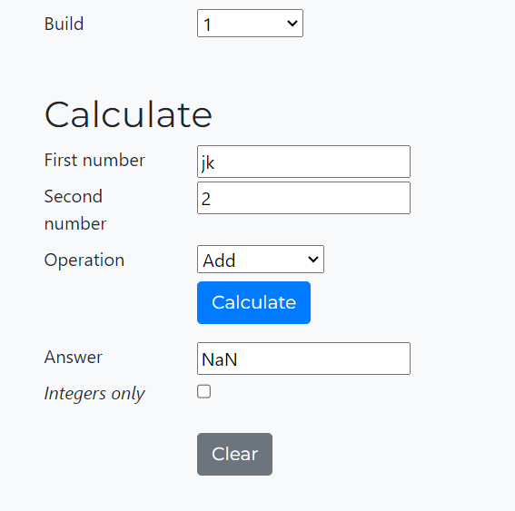

Defect ID:2

Module name: Build-2

Test data: 25,5

TestURL: https://testsheepnz.github.io/BasicCalculator.html

Defect Summary: Instead of doing addition operation the number gets concatenated.

Steps:

1.Open the browser

2.Enter the URL- https://testsheepnz.github.io/BasicCalculator.html

3.Select Build 2

4.Enter the given values in the text field

5.Click on addition from operation dropdown

6.Click on calculate

Screenshot:

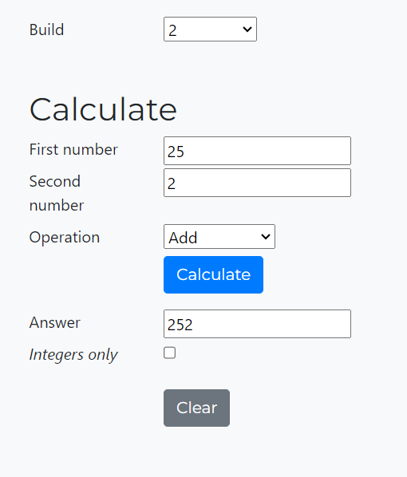

Defect ID:3

Module name: Build-2

Test data: qwe,asd

TestURL: https://testsheepnz.github.io/BasicCalculator.html

Defect Summary: It should accept the alphabets and need to perform concatenation but here it is not accepting alphabets and showing error as not a number.

Steps:

1.Open the browser

2.Enter the URL- https://testsheepnz.github.io/BasicCalculator.html

3.Select Build 2

4.Enter the given values in the text field

5.Click on concatenation from operation dropdown

6.Click on calculate

Screenshot:

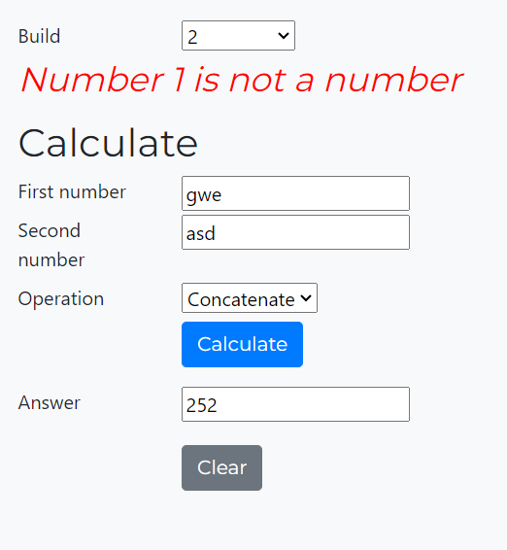

Defect ID:4

Module name: Build-3

Test data: wyz,mno

TestURL: https://testsheepnz.github.io/BasicCalculator.html

Defect Summary: Error message gets displayed and not performing concatenation.

Steps:

1.Open the browser

2.Enter the URL- https://testsheepnz.github.io/BasicCalculator.html

3.Select Build 3

4.Enter the given values in the text field

5.Click on concatenation from operation dropdown

6.Click on calculate

Screenshot:

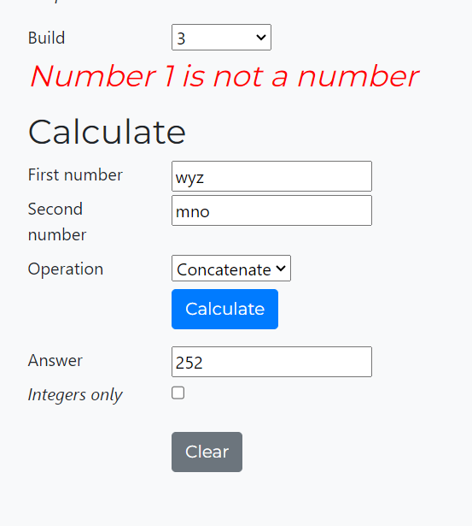

Defect ID:5

Module name: Build-4

Test data: -

TestURL: https://testsheepnz.github.io/BasicCalculator.html

Defect Summary: Integer only checkbox is selected by default and can’t able to make any changes in the checkbox.

Steps:

1.Open the browser

2.Enter the URL- https://testsheepnz.github.io/BasicCalculator.html

3.Select Build 4

Screenshot:

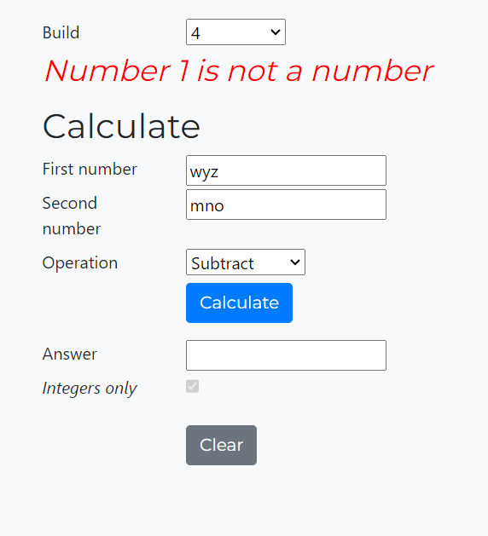

Defect ID:6

Module name: Build-7

Test data: 11,4

TestURL: https://testsheepnz.github.io/BasicCalculator.html

Defect Summary: Improper addition is performed and the result is incorrect

Steps:

1.Open the browser

2.Enter the URL- https://testsheepnz.github.io/BasicCalculator.html

3.Select Build 7

4.Enter the given values in the text field

5.Click on addition from operation dropdown

6.Click on calculate

Screenshot:

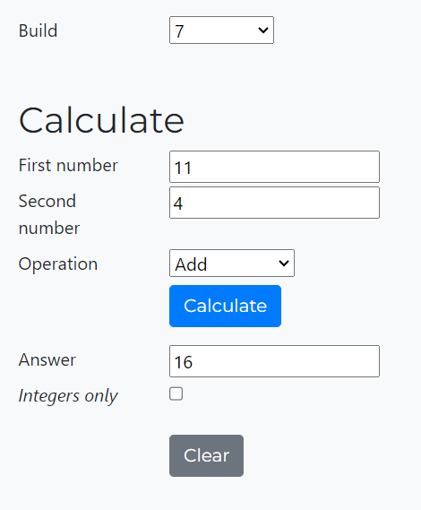

Defect ID:7

Module name: Build-7

Test data: 10,5

TestURL: https://testsheepnz.github.io/BasicCalculator.html

Defect Summary: The number which is passed for division operation and the corresponding result is not relevant to the entered values

Steps:

1.Open the browser

2.Enter the URL- https://testsheepnz.github.io/BasicCalculator.html

3.Select Build 7

4.Enter the given values in the text field

5.Click on division from operation dropdown

6.Click on calculate

Screenshot:

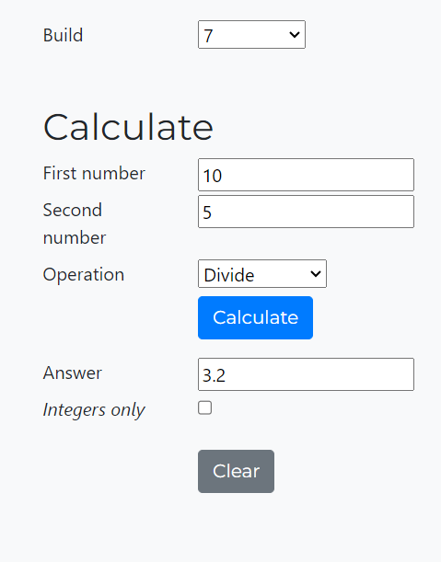

Defect ID:8

Module name: Build-7

Test data: grs,4

TestURL: https://testsheepnz.github.io/BasicCalculator.html

Defect Summary: Error message not gets displayed while entering alphabets in the textfield.

Steps:

1.Open the browser

2.Enter the URL- https://testsheepnz.github.io/BasicCalculator.html

3.Select Build 7

4.Enter the given values in the text field

5.Click on subtraction from operation dropdown

6.Click on calculate

Screenshot:

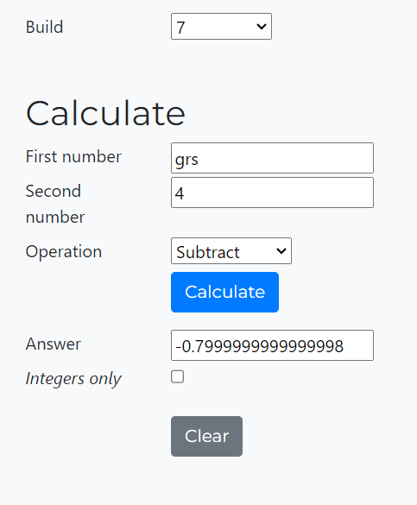

Defect ID:9

Module name: Build-8

Test data: 2, abc

TestURL: https://testsheepnz.github.io/BasicCalculator.html

Defect Summary: Proper error message not gets displayed.

Steps:

1.Open the browser

2.Enter the URL- https://testsheepnz.github.io/BasicCalculator.html

3.Select Build 8

4.Enter the given values in the text field

5.Click on addition from operation dropdown

6.Click on calculate

Screenshot:

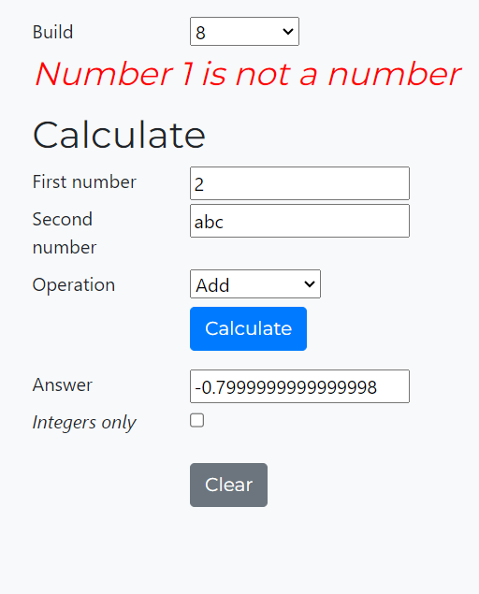

Defect ID:10

Module name: Build-8

Test data: efg,abc

TestURL: https://testsheepnz.github.io/BasicCalculator.html

Defect Summary: In this build concatenation happens in reverse order

Steps:

1.Open the browser

2.Enter the URL- https://testsheepnz.github.io/BasicCalculator.html

3.Select Build 8

4.Enter the given values in the text field

5.Click on concatenation from operation dropdown

6.Click on calculate

Screenshot:

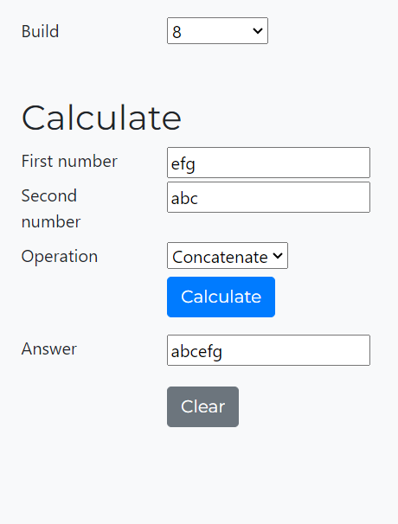

Defect ID:11

Module name: Build-9

Test data: -

TestURL: https://testsheepnz.github.io/BasicCalculator.html

Defect Summary: Only one text field gets displayed

Steps:

1.Open the browser

2.Enter the URL- https://testsheepnz.github.io/BasicCalculator.html

3.Select Build 9

Screenshot:

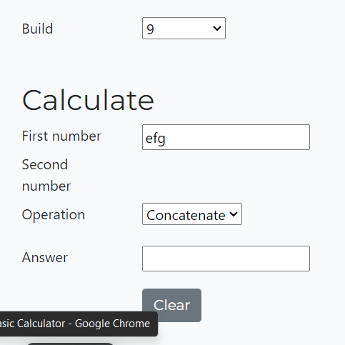

Defect ID:12

Module name: Build-9

Test data: -

TestURL: https://testsheepnz.github.io/BasicCalculator.html

Defect Summary: Calculate button is not available in build number 9.

Steps:

1.Open the browser

2.Enter the URL- https://testsheepnz.github.io/BasicCalculator.html

3.Select Build 9

Screenshot:



**AUTOMATION SCRIPT:**